**Fluid Mechanics**

**Prof. Sumesh P. Thampi**

**Department of Chemical Engineering**

**Indian Institute of Technology, Madras**

**Lecture – 02**

**Fluid statics**

Now, let us talk about pressure. So, pressure is a special kind of stress. It is also defined as force per unit area.

(Refer Slide Time: 00:25)

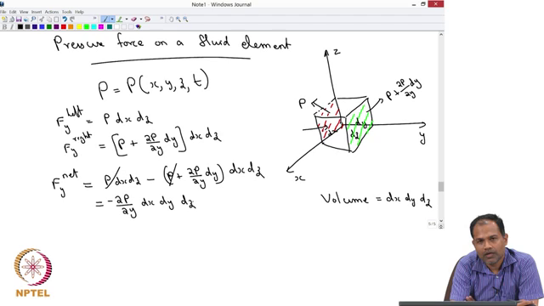

So, let us look at pressure force on a fluid element. Let us take a coordinate system. Let us say that this is x, this is y and that is z and take a fluid element. So, this has got a length d x in x direction, d y in y direction and d z in z direction. So, that the volume of this fluid element:

$$Volume=dx dy dz$$

Now, let us say this fluid element is in a given fluid where there is a pressure distribution. It means that the pressure is changing from one point to another. Let us say pressure is given as a function of x, y, z and t.

$$P=P(x,y,z,t)$$

So, pressure is changing at every point as well as in time…… ok? At any given point x, y, z and t, you know what is the pressure. Now you are going to calculate what is the pressure exerted on each face of the fluid. So, let us say we are going to look at this face. So, the face that I have marked with red color and I want to calculate what is the force on that side. So, I know that on this side of this face, I can calculate the force because pressure is defined as force per unit area. Therefore, if I want to talk about a force which is acting in the y direction on the left side of of the cube is simply going to be:

$$F_{y}^{left}=Pdx dz$$

So, that is the force going to be acting on this side of the element. Similarly, you can calculate what is the force on the other side exactly on the opposite side of the red side that I have marked. Now, we do not know what is the pressure there, but we can let us say do a Taylor expansion and write down the pressure there.

So, let us say if the pressure here is given by P, then the pressure here can be written as:

$$P+\frac{∂P }{∂y}dy$$

So, that is a simplest approximation that you can do to represent pressure on that side. So, therefore, F y on the right side is given as:

$$F_{y}^{right}=\left[P+\frac{∂P }{∂y}dy\right]dx dz$$

And your interest is to calculate what is the net force acting in the y direction, which you will get if you subtract one from the other. So, if your interest is to calculate F y net which is the force acting in the y direction, it is given as:

$$F_{y}^{net}=Pdx dz-\left[P+\frac{∂P }{∂y}dy\right]dx dz=-\frac{∂P }{∂y} dx dy dz$$

That is the force that is arising in the y direction due to a pressure. We can continue, we can do the same thing in x direction as well as in z direction.